### **What is Assurance?**

Assurance is provided by organization management, it means giving a positive declaration on a product which obtains confidence for the outcome. It gives a security that the product will work without any glitches as per the expectations or requests.

### **What is Quality Assurance?**

Quality Assurance is known as QA and focuses on preventing defects. Quality Assurance ensures that the approaches, techniques, methods and processes designed for the projects are implemented correctly.

Quality Assurance(QA) is a standard process set up by an organization to meet quality standards. This process helps to avoid mistakes and defects, delivering products and services to customers.

Quality assurance activities monitor and verify that the processes used to manage and create the deliverables have been followed and are operative.

Quality Assurance is a proactive process and is Prevention in nature. It recognizes flaws in the process. Quality Assurance has to be completed before Quality Control.

**What is Control?**

Control is to test or verify actual results by comparing it with the defined standards.

### **What is Quality Control?**

Quality Control is known as QC and focuses on identifying a defect. QC ensures that the approaches, techniques, methods and processes designed in the project are followed correctly. QC activities monitor and verify that the project deliverables meet the defined quality standards.

Quality Control is a reactive process and is detective in nature. It recognizes the defects. Quality Control has to complete after Quality Assurance.

**What is The Difference in QA/QC?**

Many people think QA and QC are the same and interchangeable but this is not true. Both are tightly linked and sometimes it is very difficult to identify the differences. Fact is both are related to each other but they are different in origins. QA and QC both are part of Quality Management however QA is focusing on preventing defects while QC is focusing on identifying the defect.

we can better understand that the QC role is to conduct tests and verify by evidence that the product meets the specified requirements. The QA role is to verify the QC tests are conducted in accordance with the appropriate standard

QC focuses on finding and fixing mistakes, and QA makes sure that mistakes don’t happen in the first place;

## Quality Assurance vs Quality Control

| **Quality Control** | **Quality Assurance** |
| --- | --- |
| QC looks for defects in a product so they can be fixed | QA ensures that what’s being made meets specific standards. |
| QC inspects and tests what’s been made to ensure it’s right | QA works on the design and development of the product to ensure it meets requirements from the start. |
| Quality Control is all about finding and fixing mistakes | Quality Assurance is focused on making sure mistakes don’t happen in the first place. |

## **Testing vs QA**

Testing and Quality Assurance are distinct processes. Testing evaluates a software system’s components to determine if it meets specified requirements. Quality Assurance, on the other hand, is a process-oriented approach that seeks to improve the software development process to ensure the delivery of high-quality software. The primary objective of Testing is to identify defects and assess software quality, while Quality Assurance aims to prevent defects and enhance overall software quality.

| **Testing** | **QA** |
| --- | --- |
| Focuses on finding defects in the software. | Focuses on improving the software development process. |
| Conducted after the development process and is conducted by Testers. | Conducted during the development process, integrated into the development process, and conducted by both developers and testers. |
| Emphasis is on identifying defects and validating software quality. | Emphasis is on preventing defects and improving software quality. |
| The objective is to find software defects and ensure it meets requirements. | The objective is to improve the software development process to make high-quality software. |

**Quality Control using Audits: - > raise Non Compliance - > Doesn’t have req clarification tracker**

Quality Audits are the onsite evaluation of a process to ensure compliance with the requirements. They are performed under the supervision of an auditor who checks whether set guidelines were practiced during the making of the product.

Audits are not about checking the product quality but about inspecting the type of work done in making a product. It evaluates how closely the prescribed model was followed. Are there any variations? If yes, then what is the reason behind variations?

The objective of audits is to continuously improve the quality of the work henceforth increasing product quality. Inspection can be one of the aspects of an Audit.

In short, the audit examines the quality of the process used while making a product. Inspection is about examining how well the product fits the requirements provided by stakeholders.

Quality and inspection are practiced in various industries, such as software, manufacturing, automobile, retail, etc., to ensure all follow a standard procedure and practice.

**Responsibilities of QA engineers:**

* Monitor every phase of the software development process, including design, development, testing, debugging, and delivery
* Maintain the quality standards of the software at every stage
* Ensure the final product meets the requirement
* Design processes, such as documenting standard operating procedures (SOPs) according to ISO 9000 standards
* Involve in the planning and monitoring of the testing processes

**Responsibilities of QC engineers:**

* Ensure all products in their company meet the set quality standards
* Assess the production process
* Create new manufacturing checkpoints
* Test the products
* Generate reports on the products or results
* Monitor and test product quality
* Ensure compliance with standards
* Identify issues
* Recommend solutions
* Offer recommendations on how to fix defects to meet the regulations and requirements

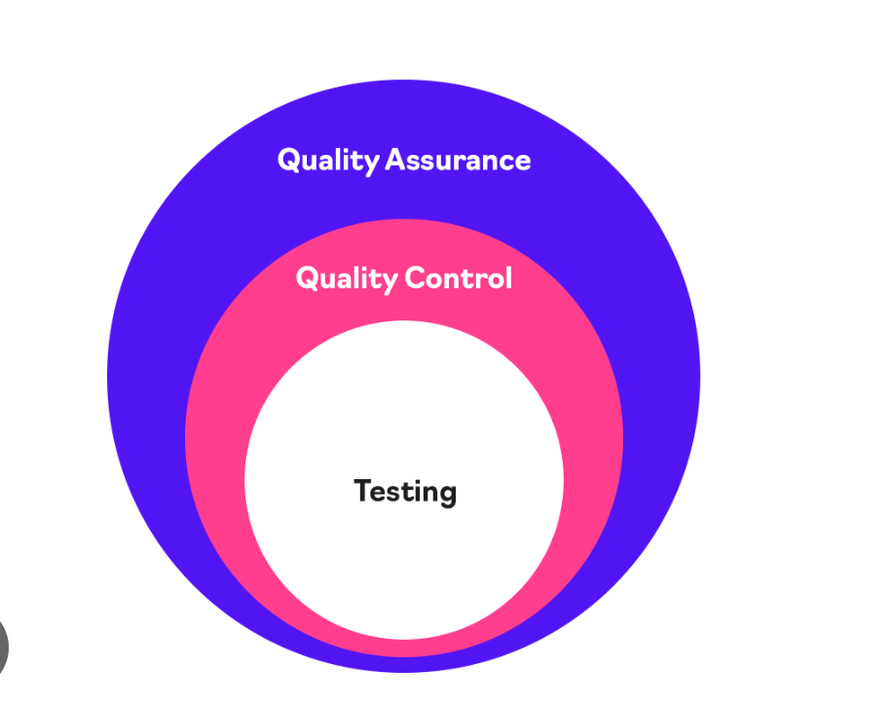

* **Quality assurance**
* A set of processes that help avoid defects and assure quality. QA is process oriented and focuses on ensuring that software meets high standards and performs flawlessly. QA is completed before QC.
* **Quality control**
* A set of activities that help detect defects and quality issues before the products reach the hands of end customers. QC is product oriented and focuses on making sure that software functions as it should. QC is reactive and detection and focuses on examining the quality of the end products and the final outcome.
* **Testing**
* One of the ways of detecting defects. Testing is a subset of QC. Testing involves identifying bugs/errors/defects in a software without correcting it.

QA is a broad process for preventing quality failures. The QA team is involved in all stages of a product's development: